Preview of table memberships before normalization:

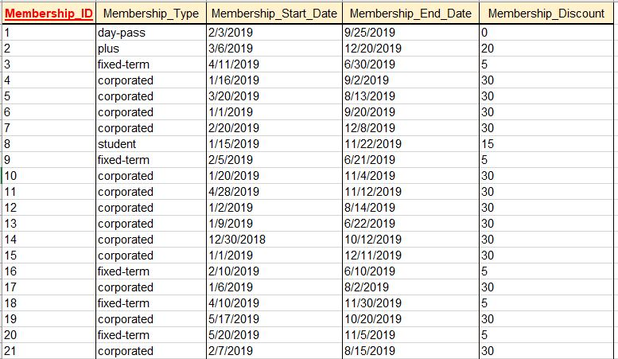

1NF

Entity is in 1NF.

PK is Membership_ID

2NF

All the attribute is depended on PK and entity is in 1NF.

3NF

Attribute membership_discount is depend on membership_type, and it can be found by knowing what is membership type. It is redundant and transitive, it will be removed.

Preview of table memberships after normalization:

